**PRACTICAL 2**

**Storage as a service using AWS.**

A: uploading photo

1:Go to storage then select s3

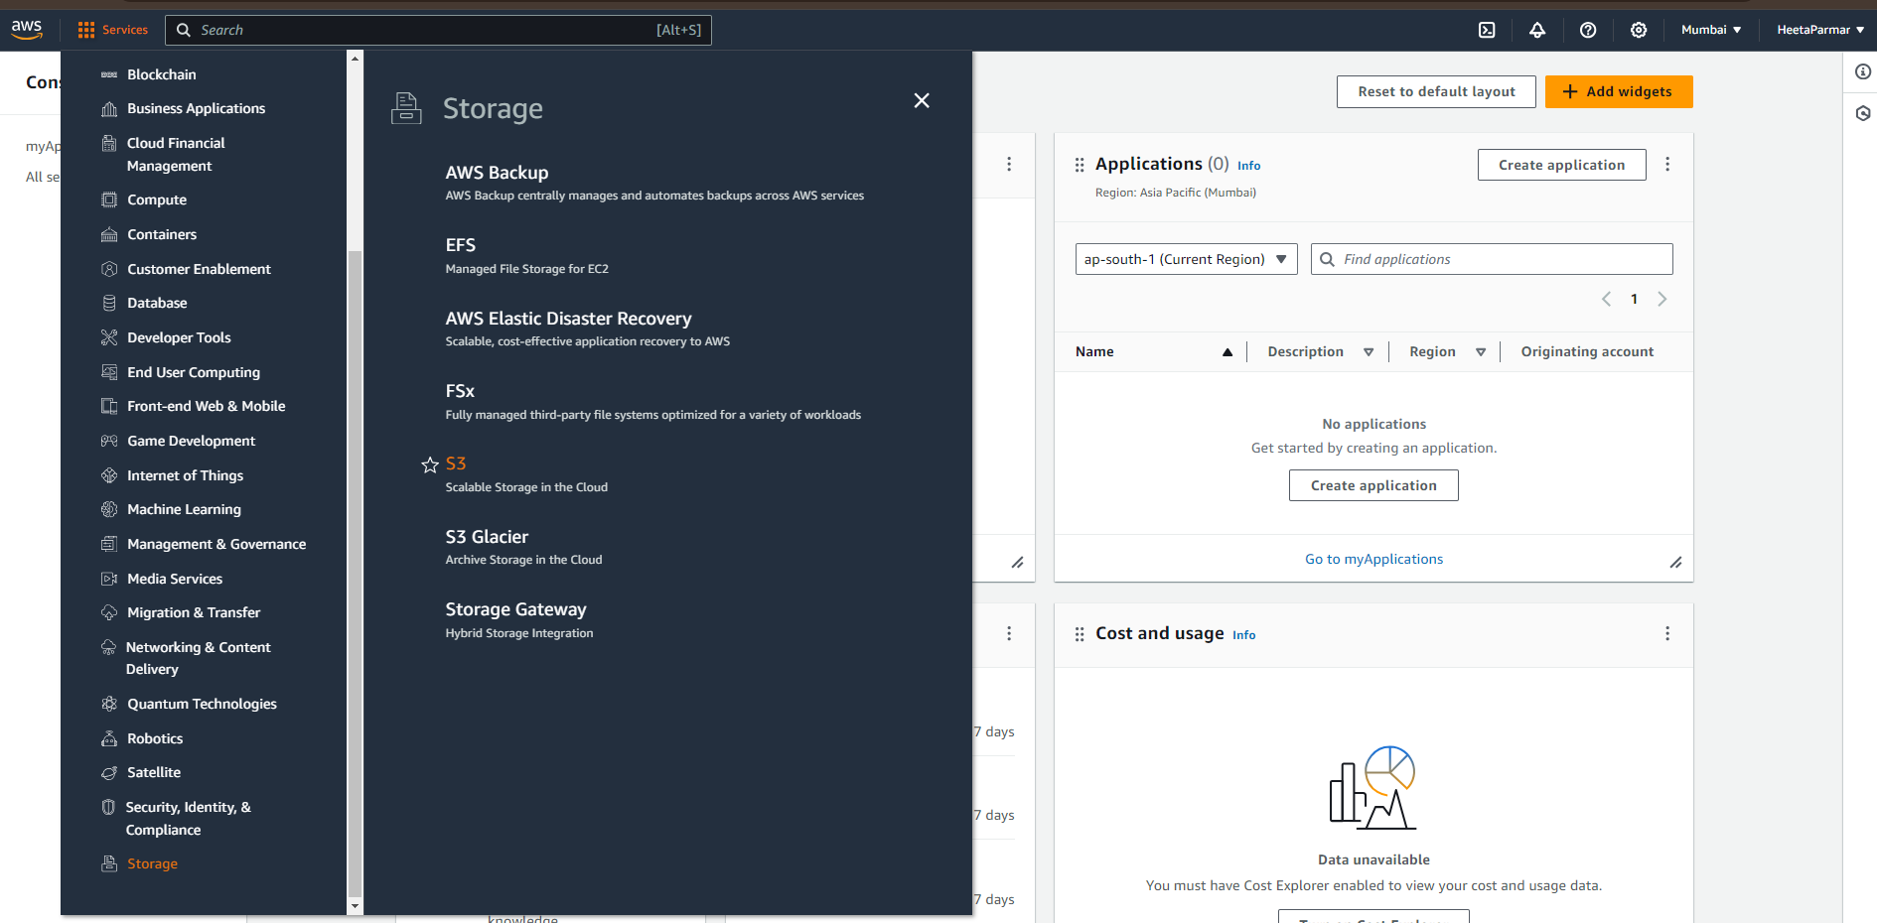

STEP 2: Create bucket

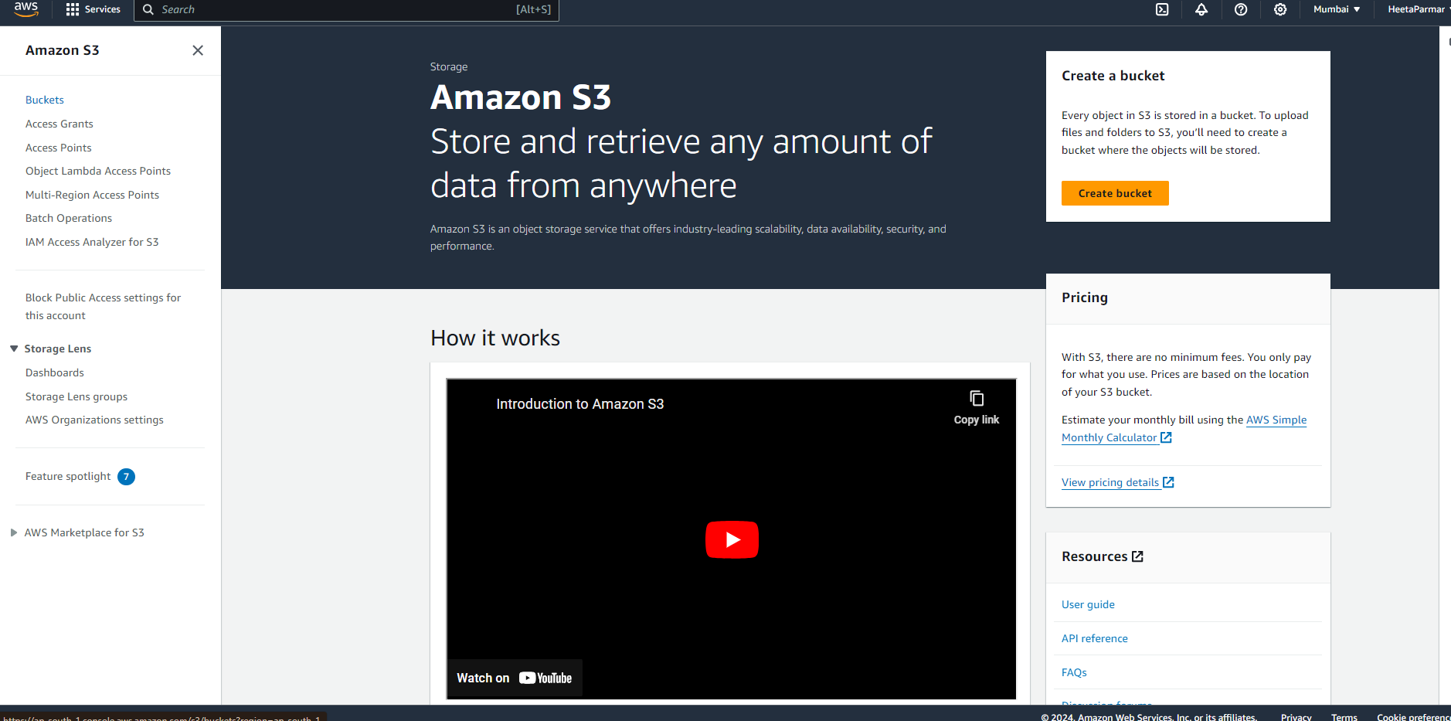

Enter bucket name my aws bucket

ACL –user and credentials disabled

Click block all public access

Disable bucket keys

3: Create bucket

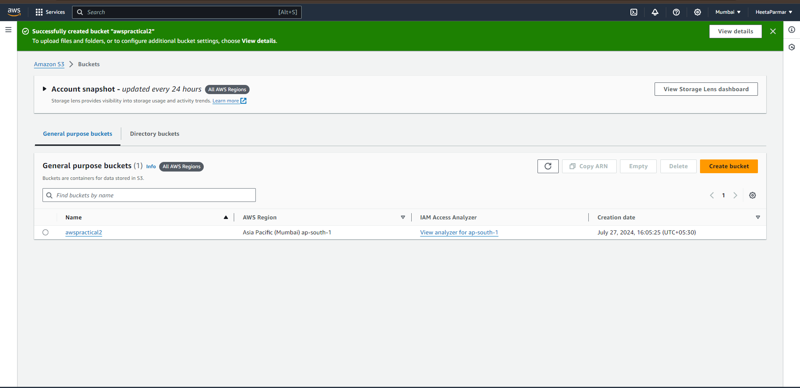

4:Create folder server encryption create folder

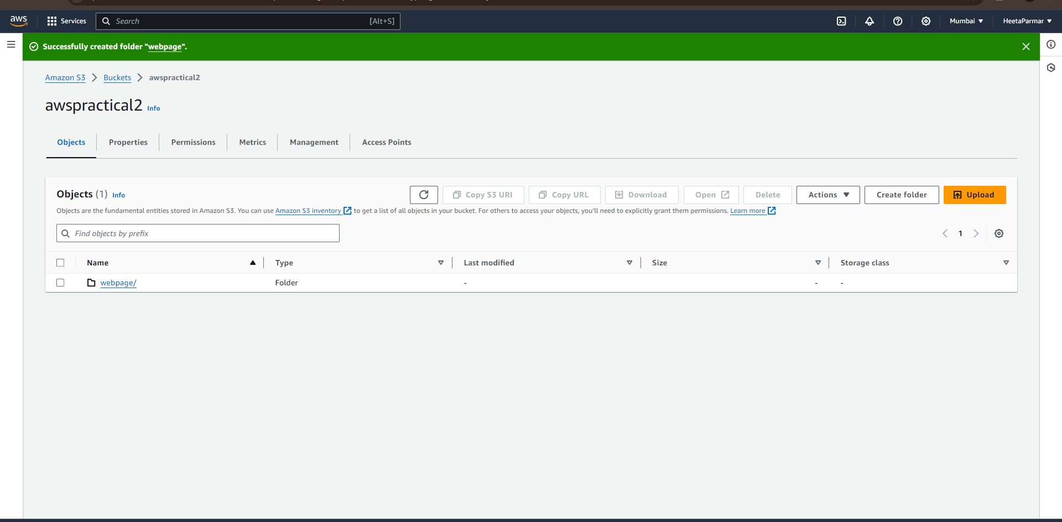

5:Upload add files

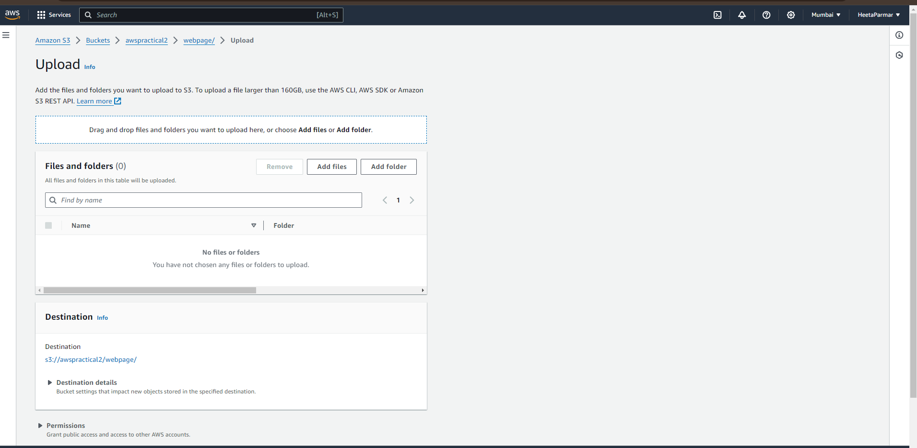

6: Uploading the image

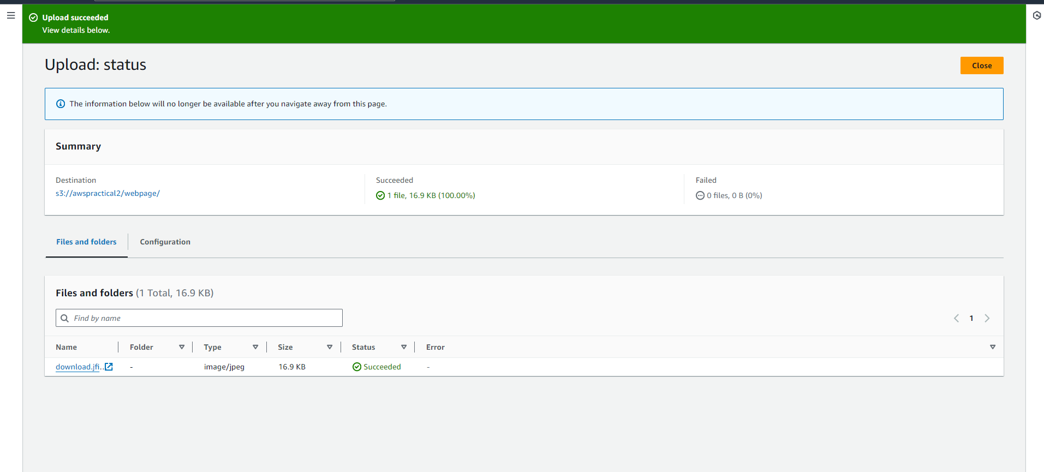

#this is showing error cause we have block the access

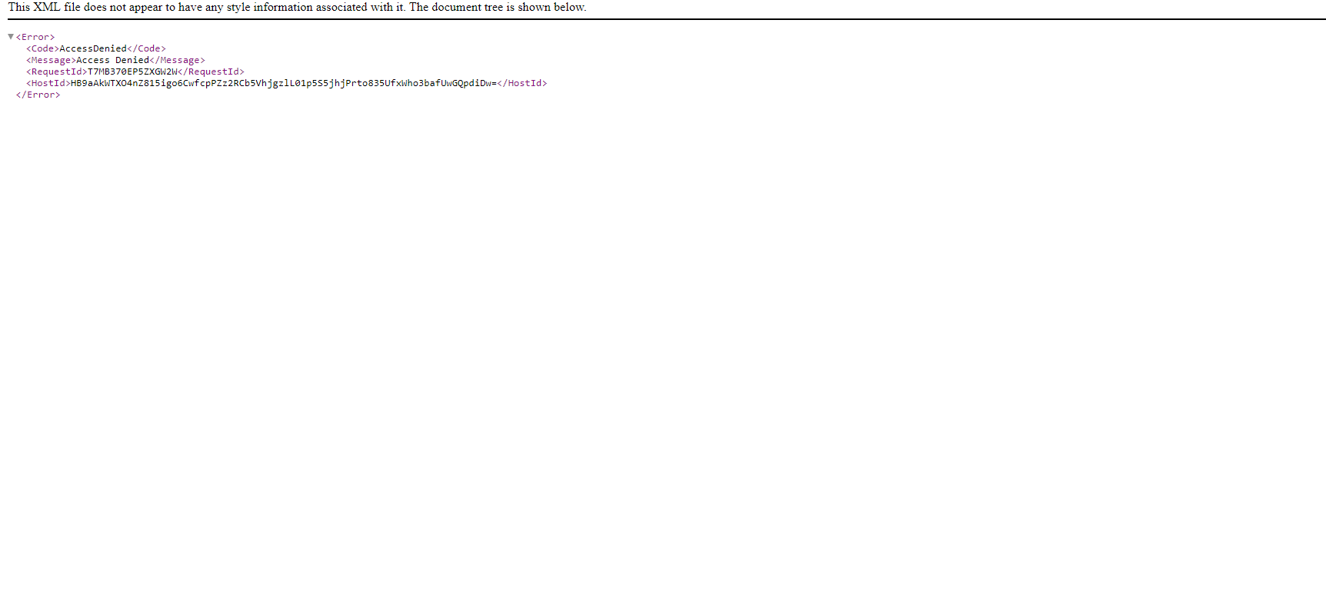

#in order to open or view the image

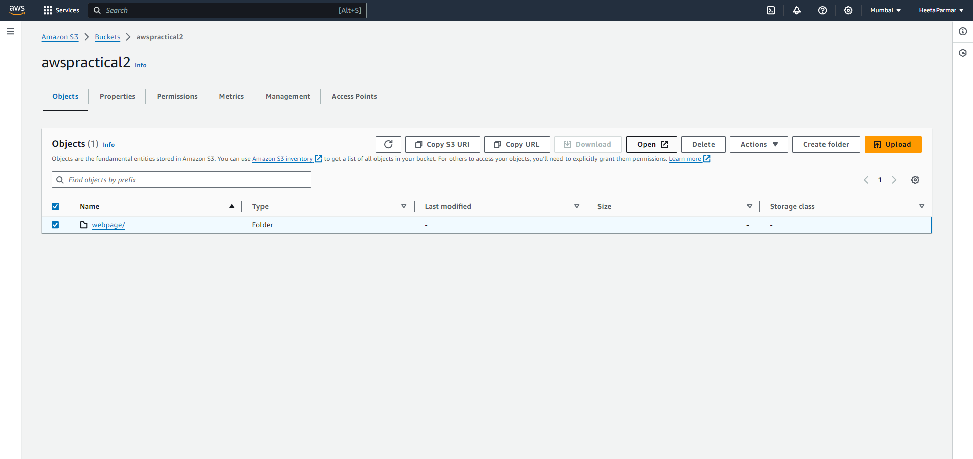

B)website upload

(Rest all steps are same )

In order to upload a webpage which has images / videos the image and the video should be uploaded in the same folder or else it will not display the image .

